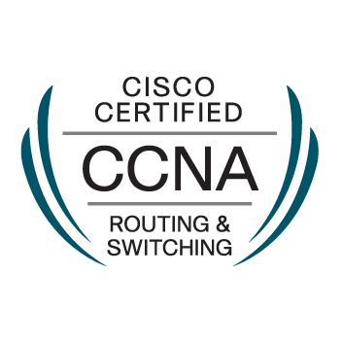

**VINODH TANKASALA**

San Jose, CA, vinodh.tankasala@sjsu.edu, (669)-261-3921

https://www.linkedin.com/in/vinodh-tankasala-4a4361b5/

 **Professional Experience:**

**Student Assistant (Lab Admin in Cisco Lab) – San Jose State University 2017 - 2018**

* Maintained Cisco routers and switches. Helped students to configure OSPF, EIGRP, RIP and BGP protocols on Cisco lab routers.
* Troubleshooted the routers (routing protocols) and switches (VLANs, STP).

**Wireless Network Engineering Intern – IIT, Hyderabad 2015**

* I was part of a team that was involved in the development of 4G modem algorithms development. During this time, I was trained in basic DSP algorithms and implementing them using C programming. I successfully completed in designing floating and fixed-point filters for multi-core filters.

**Technical Skills:**

**Programming Languages:** C, Python 2.7, Perl, Linux Shell commands.

**Cloud Computing:** Amazon AWS – EC2, S3, ELB, VPC & Route 53

**Network Technologies:** SSH, SNMP, DNS, IPsec, HTTP / HTTPS, FTP, routing/switching, Experience in supporting and testing LANs, WLANs, TCP, UDP, DHCP servers, VPNs, NAT devices, Subnetting, OSPF, RIP, BGP, EIGRP, IS-IS, Troubleshooting knowledge across L2 and L3 devices.

**Operating Systems:** Windows, unix/Linux environments, Ubuntu, & Kali Linux

**Tools:** Wireshark, TCPDUMP, VMWare, Cisco Packet Tracer, GNS3, NS3, CLI, PuTTY

**Certifications:**

* Cisco Certified Network Associate (CCNA – Routing & Switching). CISCO ID – CSCO13028560

**Course Projects:**

**DDOS Attack Using Traffic Generator [Tools: NS-2, Python, Linux]:** Implemented Distributed-Denial-of-service (DDoS) attack with the help of a traffic generator over a targeted system and analyzed the impact of this attack on the victim as well as the network. **Spring ‘18**

**Big Fun Network with 3000 nodes [Tools: Cisco VIRL, Ansible, AutoNetkit, VM maestro, Python, Jenkins]:** Deployment of a large virtual network of 3000 nodes that consists of multiple VIRL instances and GNS3 instances with routing enabled and deployed using Ansible Network Automation. **Fall ‘17**

**Man In The Middle Attack Using BGP Prefix Hijacking [Tools: Python, Linux, DETERLAB]:** Devised and carried a web MITM attack in DETERLAB testbed and demonstrated defensive mechanisms to prevent BGP hijacking. **Spring ‘17**

**Performance and analysis of AD-HOC Protocols [Tools: Linux, NS-3, Python, Wireshark]:** Developed different AD-HOC networks with multiple mobile nodes and background traffic. Configured the network with AD-HOC protocols (**AODV, DSDV, DSR, TORA)** and studied the results. **Fall ‘17**

**Software Firewall [Tools: Linux, GNS3, Wireshark, Python]:** Designed a firewall program using python language which examines the layer-3 header of a packet and allows, or blocks packet based on the underlying transport layer protocol or IP address or protocol type. **Fall ‘16**

**Chat Application Using WEBRTC [Tools: Python, C++, Linux]:** Developed an internet group chat application (client-server architecture) using python language. This Application uses stream sockets for communication. Comprises of client and server codes for Linux platforms. It also includes password authorization and multi-threading features. **Fall ‘16**

**Education:**

**Master’s, Electrical Engineering** [Computer Networking], San Jose State University, CA  May ’18

**B. Tech Electronics and Communication Engineering**, Gitam University, India April ‘16